SQL QUERIES

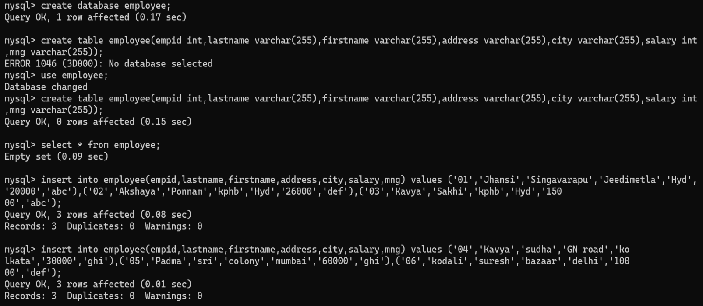Create a database:

Create table:

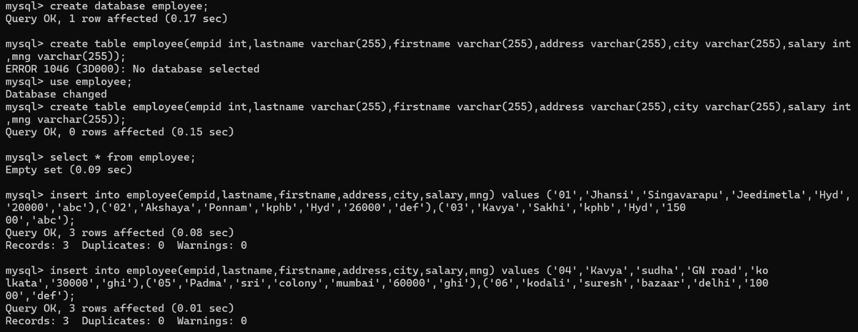

Insert values:

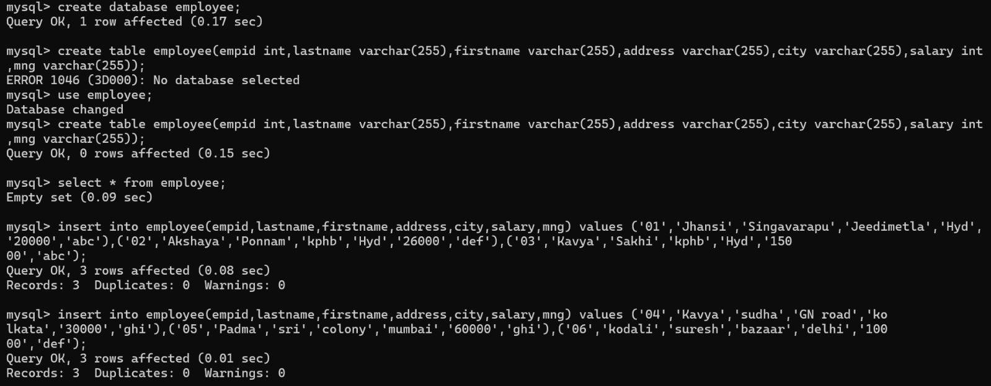

Display record:

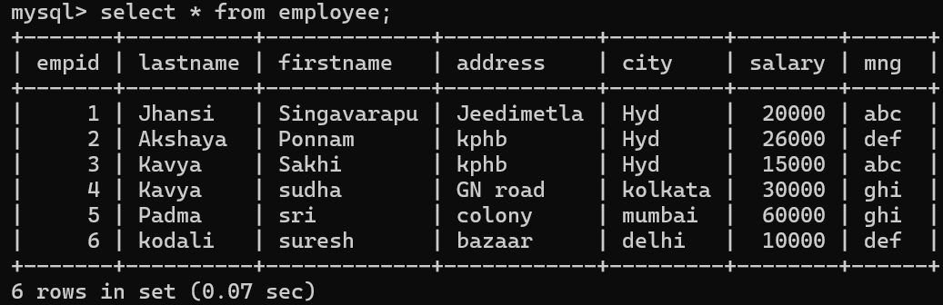

Is null and Not Null:

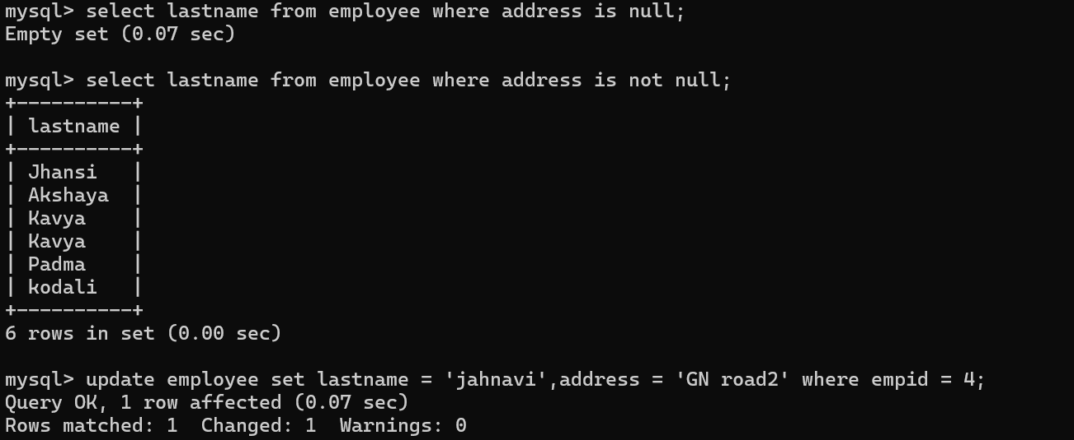

Update the values: 

To display limited values:

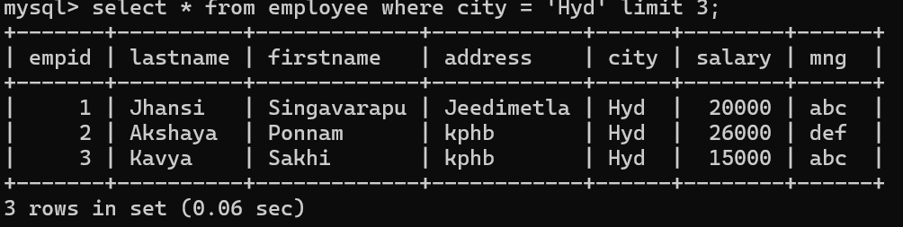

AGGREGATE FUNCTIONS:

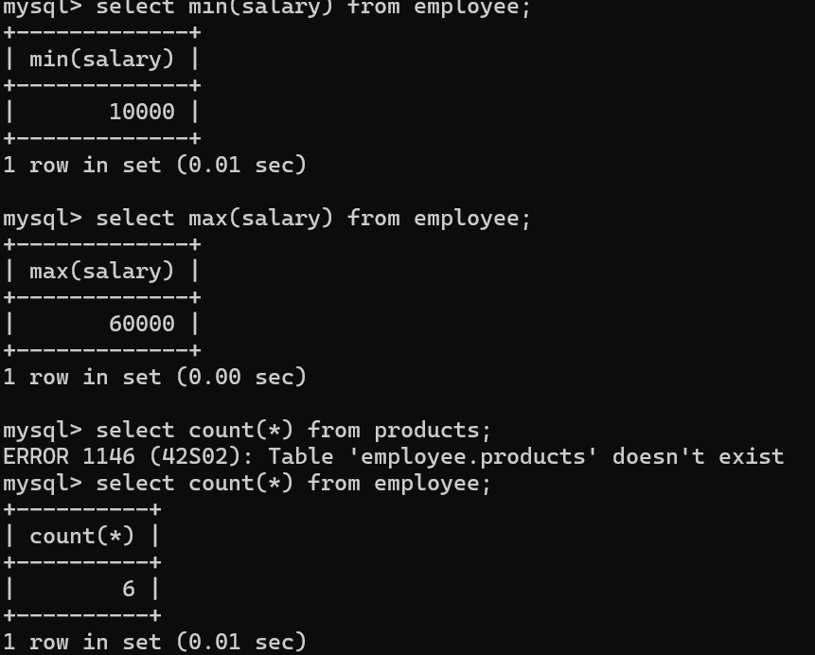

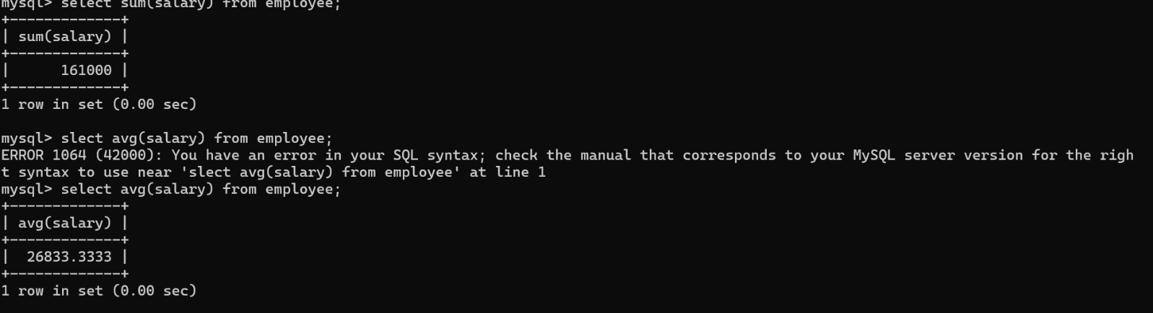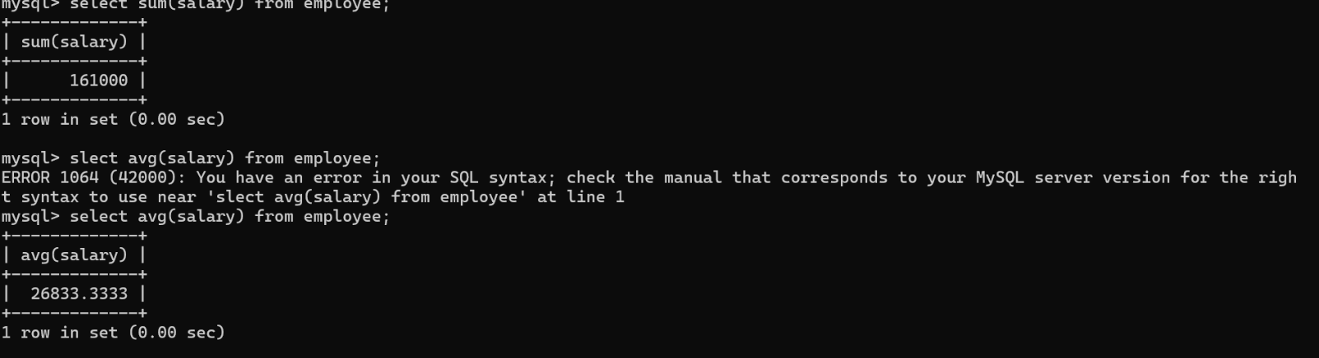

JOINS:

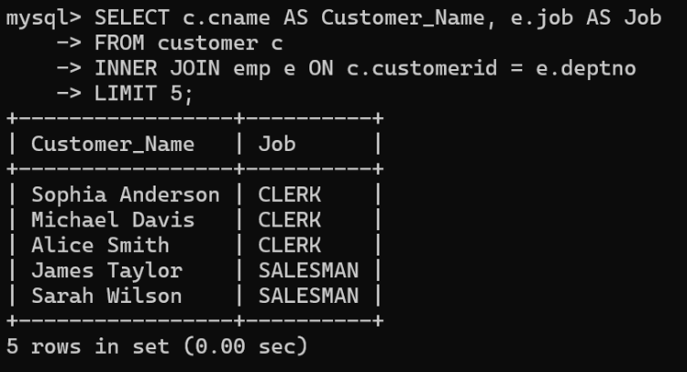Table1 Table 2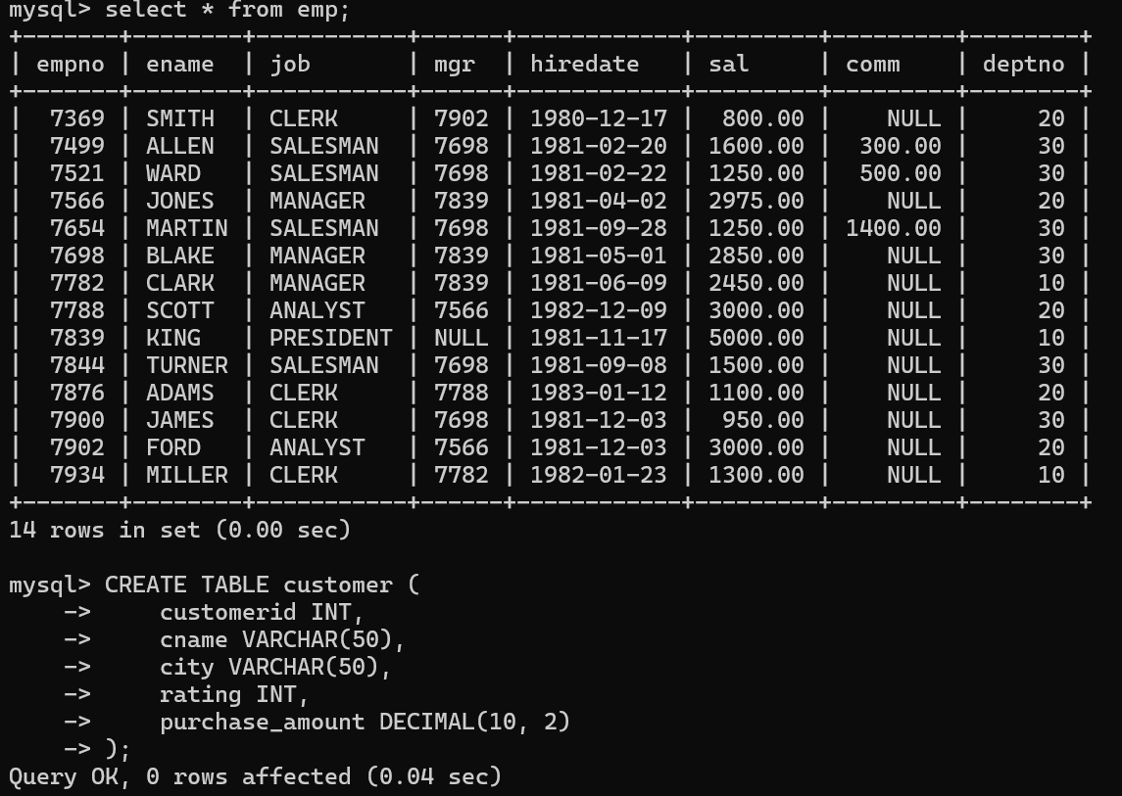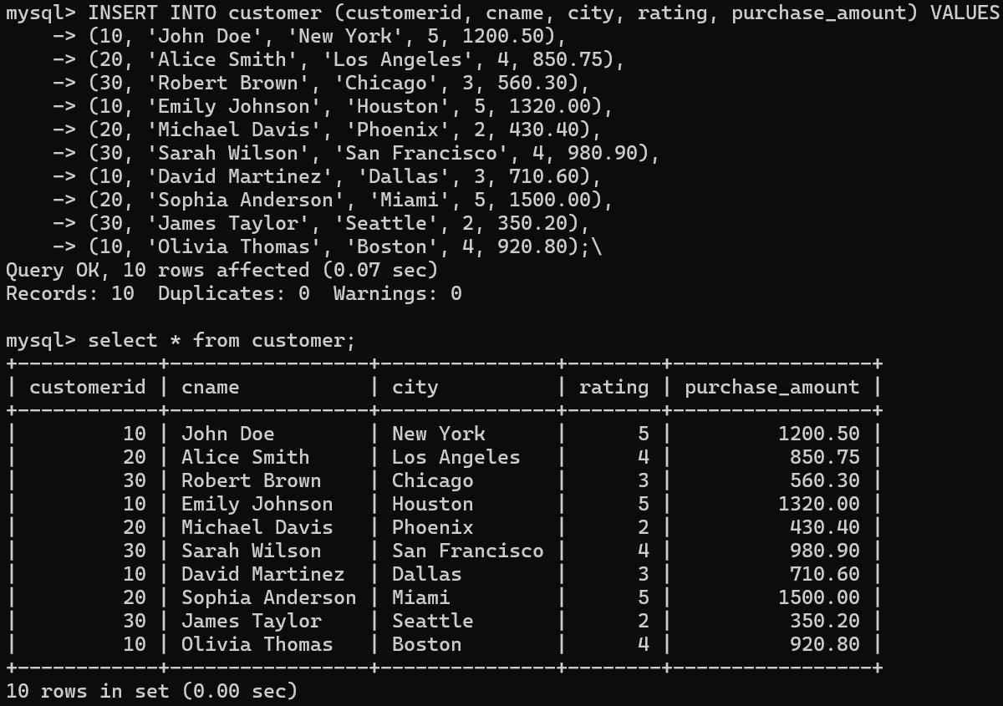

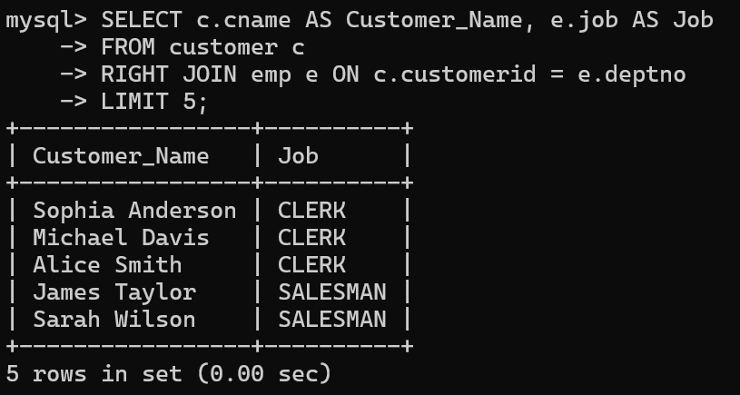

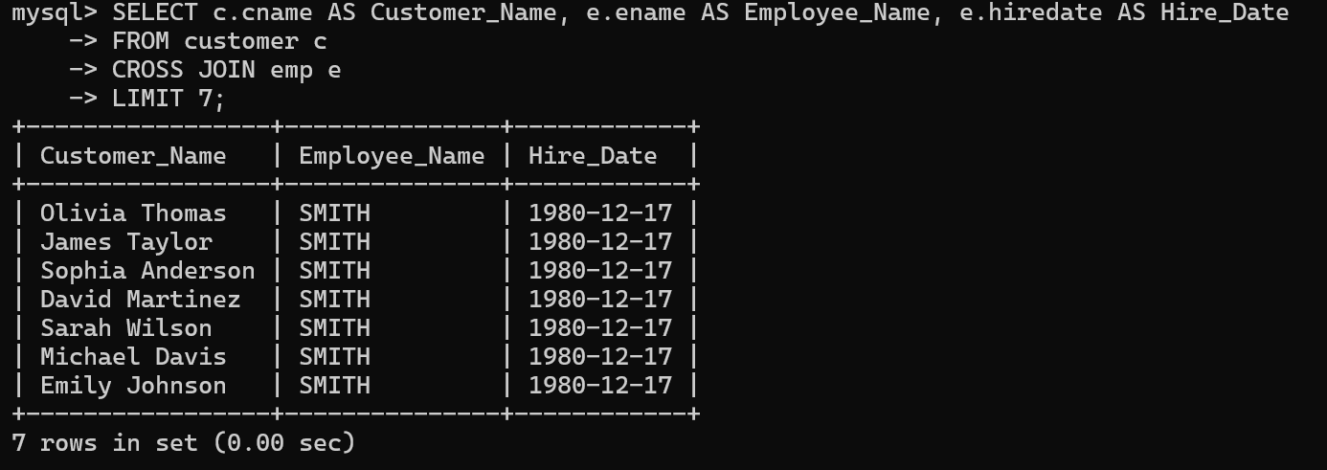

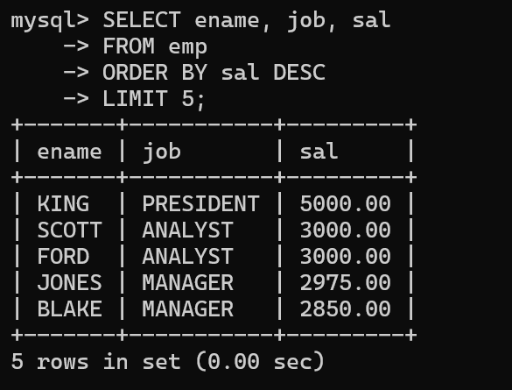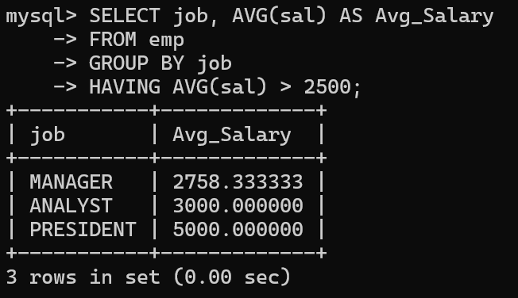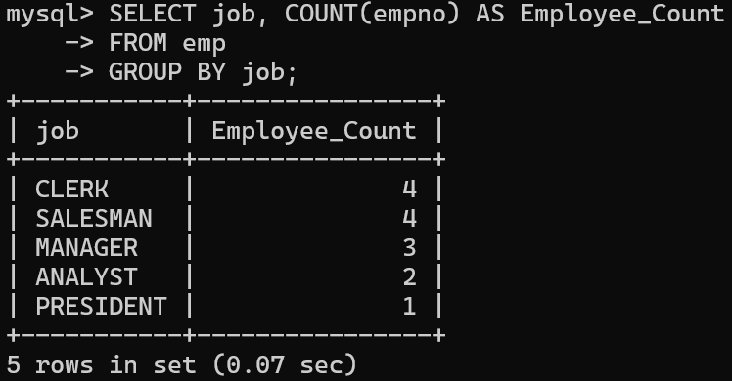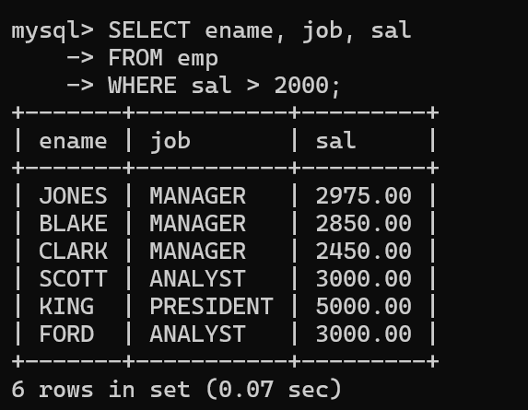CLAUSES:



EXISTS:

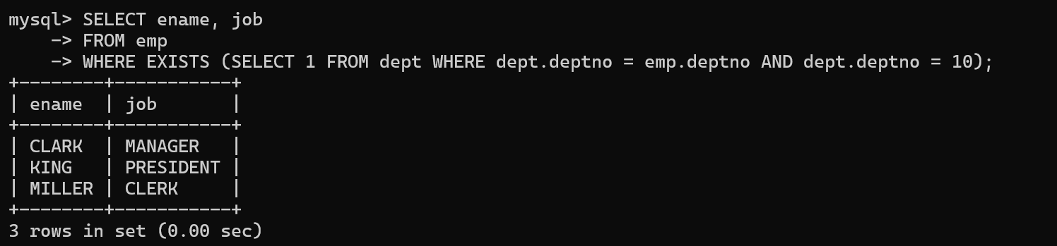

WILCARDS:

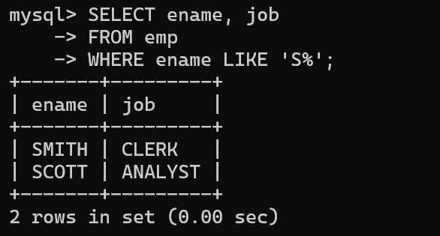

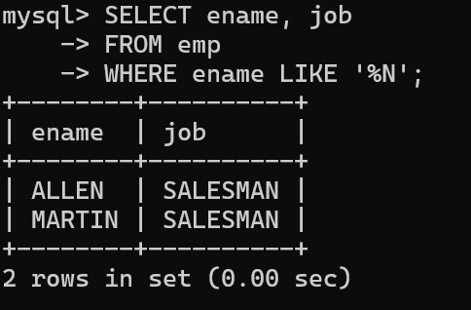

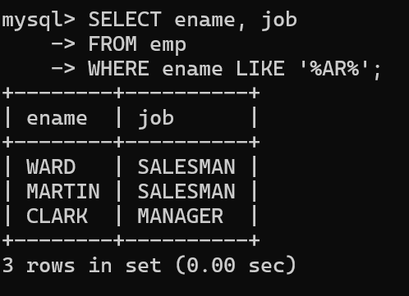

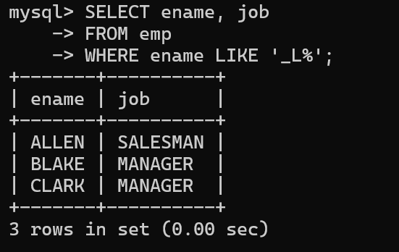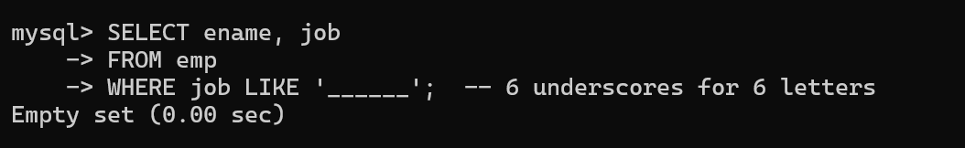

ALTER COMMANDS:

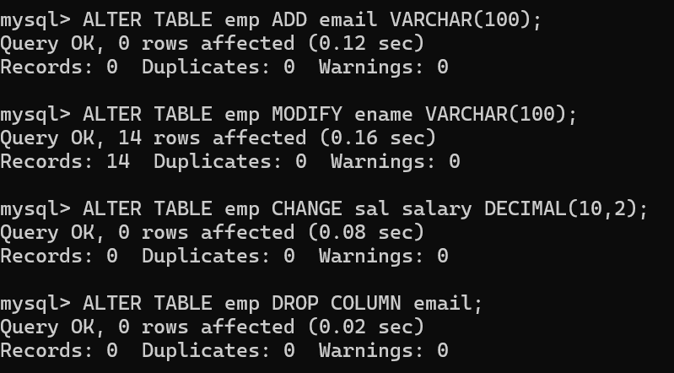

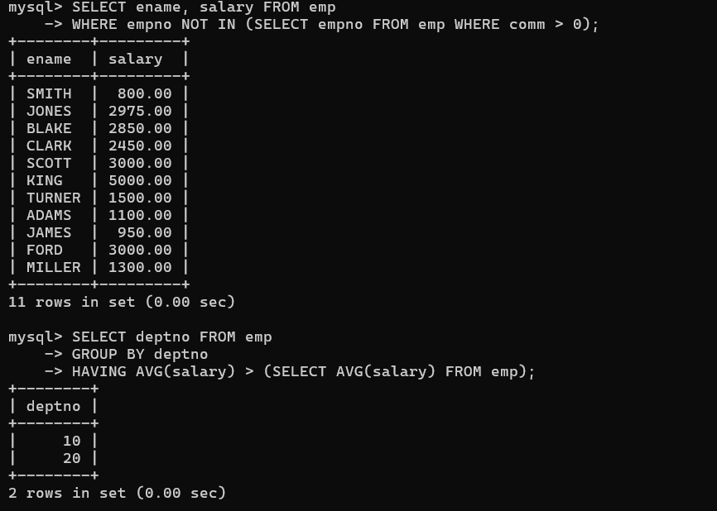SUBQUERIES:

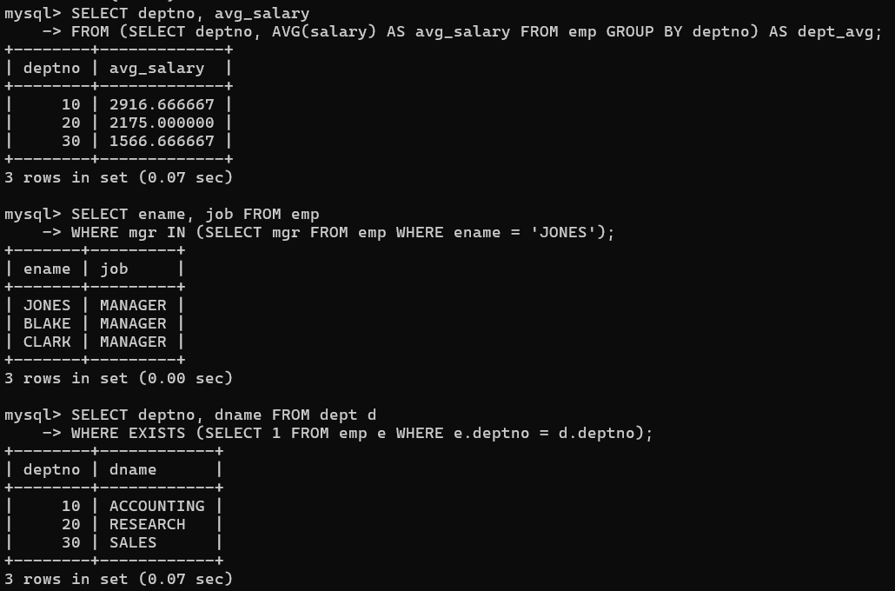

SQL COMMANDS:

1.DDL

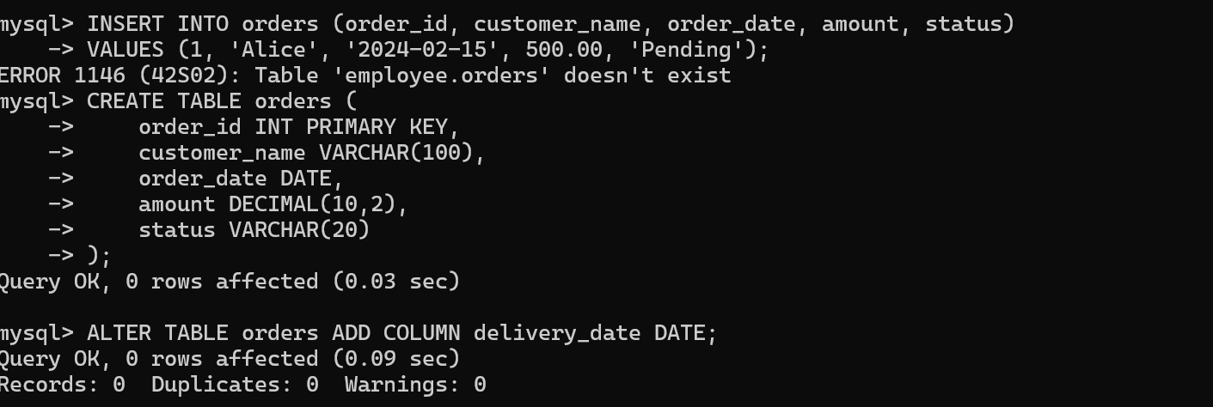

2.DML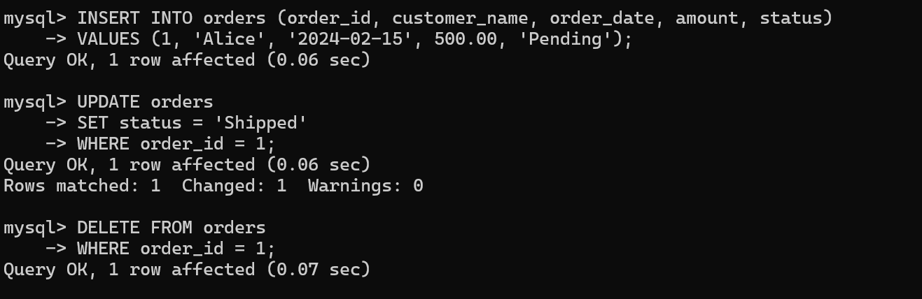

3.DQL

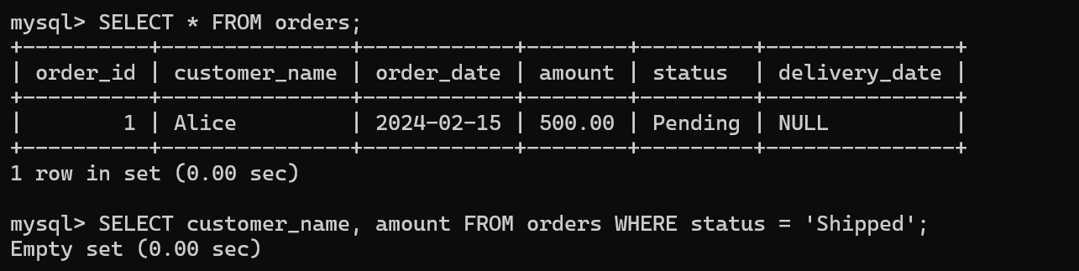

4.TCL

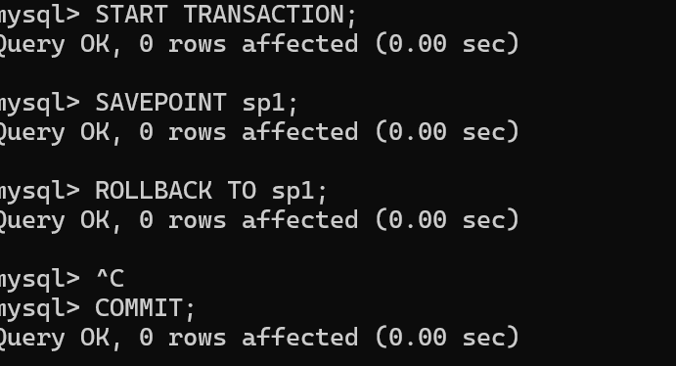

And

SELECT *

FROM Customers

WHERE Country = 'Spain' AND CustomerName LIKE 'G%';

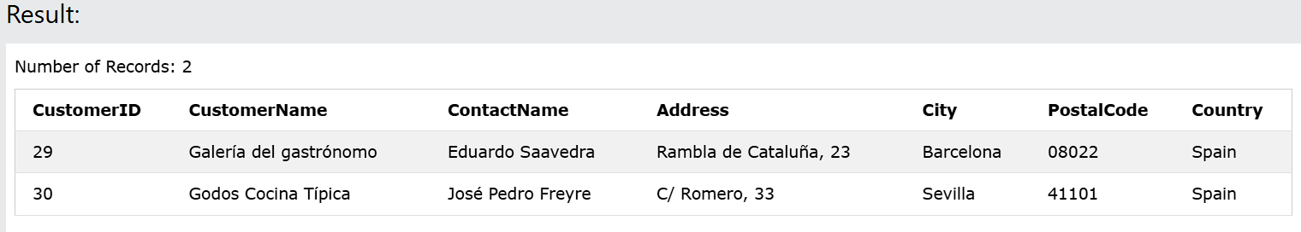

**Distinct**

SELECT DISTINCT Country FROM Customers;

Number of Records: 21

|  |
| --- |
| **Country** |
| Argentina |
| Austria |
| Belgium |
| Brazil |
| Canada |
| Denmark |
| Finland |
| France |
| Germany |
| Ireland |
| Italy |
| Mexico |
| Norway |
| Poland |
| Portugal |
| Spain |
| Sweden |
| Switzerland |
| UK |
| USA |
| Venezuela |

**OR**

SELECT *  
FROM Customers  
WHERE Country = 'Germany' OR Country = 'Spain';

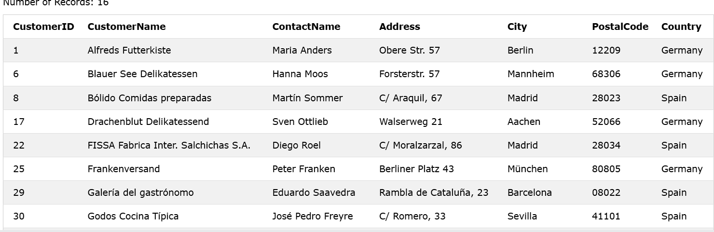

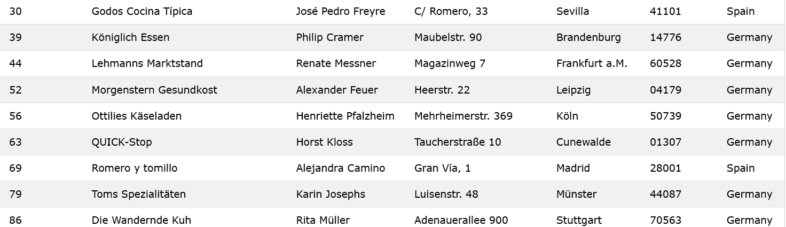

**SELECT TOP**

SELECT TOP 3 * FROM Customers;

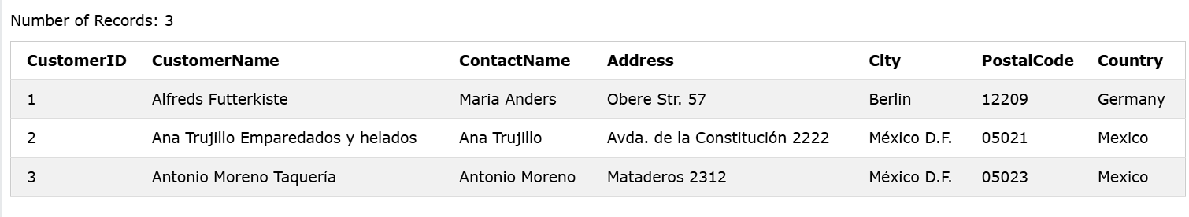

**ALIASES**

SELECT CustomerID AS ID

FROM Customers;

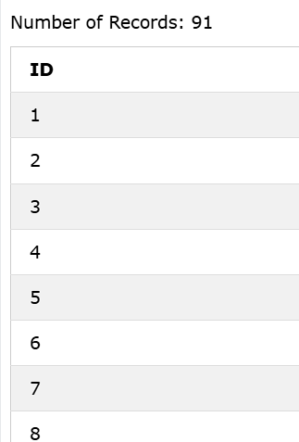

**IN**

SELECT * FROM Customers

WHERE Country IN ('Germany', 'France', 'UK');

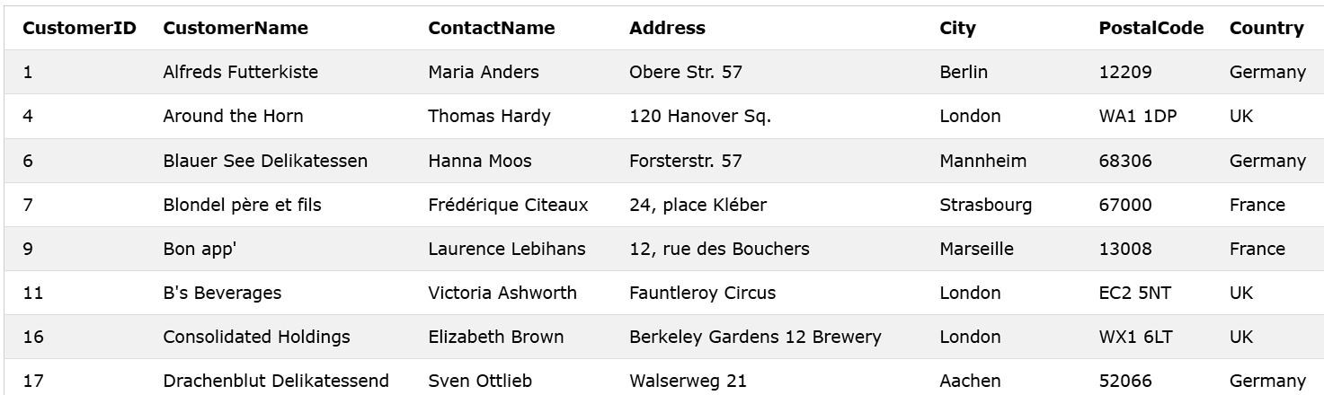

**BETWEEN**

SELECT * FROM Products  
WHERE Price BETWEEN 10 AND 20;

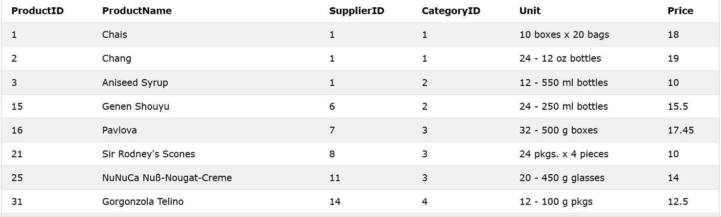

**LEFT JOIN**

SELECT Customers.CustomerName, Orders.OrderID  
FROM Customers  
LEFT JOIN Orders ON Customers.CustomerID = Orders.CustomerID  
ORDER BY Customers.CustomerName;

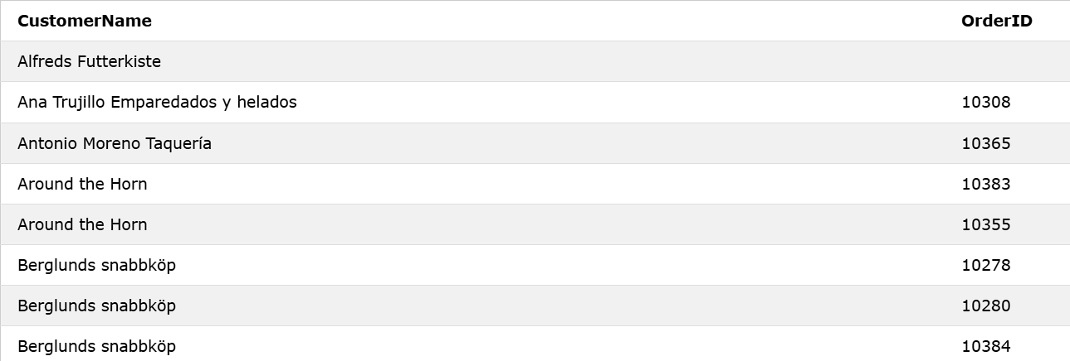

**UNION**

SELECT City FROM Customers  
UNION  
SELECT City FROM Suppliers  
ORDER BY City;

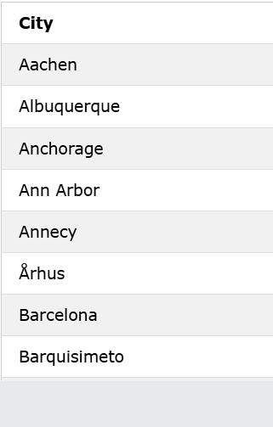

**ANY**

SELECT ProductName  
FROM Products  
WHERE ProductID = ANY  
  (SELECT ProductID  
  FROM OrderDetails  
  WHERE Quantity = 10);

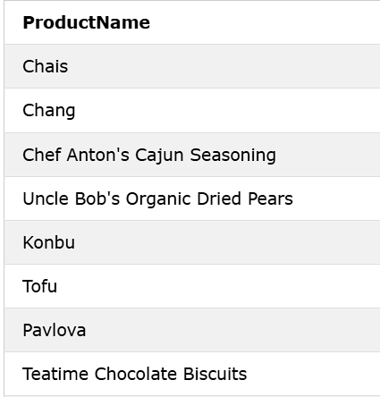

**ALL**

SELECT ALL ProductName  
FROM Products  
WHERE TRUE;

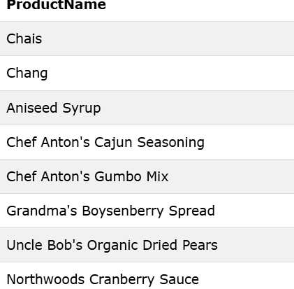

**CONSTRAINTS**

**1.NOT NULL**

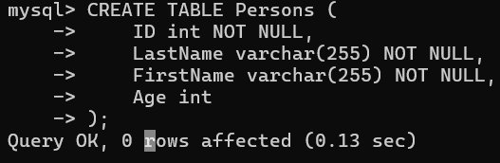

**2.UNIQUE KEY**

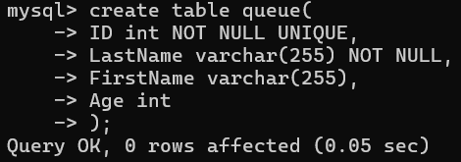

**3.PRIMARY KEY**

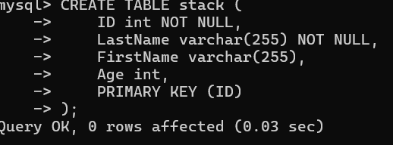

**4.FOREIGN KEY**

**5.CHECK**

